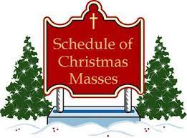

By Churches

St. Boniface Church Holy Rosary Church
Dec. 24, 2022 5:15 p.m. Dec. 24, 2022 6:00 p.m.
11:00 p.m. 9:00 p.m.
Dec. 25, 2022 8:00 a.m. Dec. 25, 2022 10:00 a.m.
St. Anne’s 8:30 a.m.
Queen of the World Church Sacred Heart Church
Dec. 24, 2022 5:00 p.m. Dec. 24, 2022 4:00 p.m.
9:00 p.m. 12:00 a.m.
Dec. 25, 2022 9:00 a.m. Dec. 25, 2022 7:00 a.m.
11:00 a.m.
St. Leo’s Church St. Marys Church
Dec. 24, 2022 4:00 p.m. Dec. 24, 2022 4:30 p.m.
10:00 p.m. 10:00 p.m.
Dec. 25, 2022 10:00 a.m. Dec. 25, 2022 7:30 a.m.
10:30 a.m.
St. Joseph Church
Dec. 24, 2022 4:30 p.m.
10:00 p.m.
Dec. 25, 2022 9:15 a.m.

By Date & Time

December 24, 2022  Sacred Heart 4:00 p.m.  St. Leo’s 4:00 p.m.  St. Marys 4:30 p.m.  St. Joseph’s 4:30 p.m.  Queen of the World 5:00 p.m.  St. Boniface 5:15 p.m.  Holy Rosary 6:00 p.m.  St. Leo’s 6:00 p.m.  Holy Rosary 9:00 p.m.  St. Joseph’s 10:00 p.m.  St. Leo’s 10:00 p.m.  St. Marys 10:00 p.m.  St. Boniface 11:00 p.m. | December 25, 2022  Sacred Heart 12:00 a.m.  Sacred Heart 7:00 a.m.  St. Marys 7:30 a.m.  St. Boniface 8:00 a.m.  Holy Rosary/St. Anne’s 8:30 a.m.  Queen of the World 9:00 a.m.  St. Joseph 9:15 a.m.  Holy Rosary 10:00 a.m.  St. Leo’s 10:00 a.m.  St. Mary’s 10:30 a.m.  Sacred Heart 11:00 a.m.

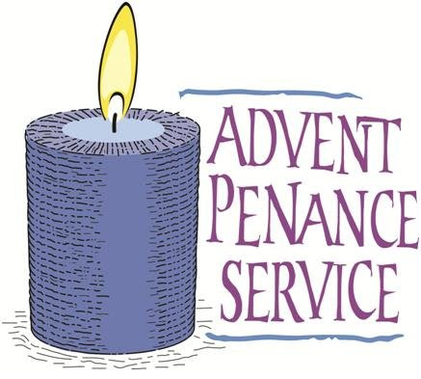

By Churches

St. Boniface Church Holy Rosary Church
Mon. Dec. 19 6:30 p.m. Mon. Dec. 5 6:30 p.m.

Queen of the World Church St. Joseph Church
Thurs. Dec. 1 4:00 p.m. Sun. Dec. 18 2:00 p.m.

Sacred Heart Church St. Leo’s Church
Thurs. Dec. 15 6:30 p.m. Wed., Dec. 21 6:30 p.m.

St. Mark’s Church St. Marys Church
Sun., Dec. 11 4:00 p.m. Tues., Dec. 20 6:30 p.m.

By Date & Time
Thursday, Dec. 1, 2022 Queen of the World (St. Marys) 4:00 p.m.
Monday, Dec. 5, 2022 Holy Rosary (Johnsonburg) 6:30 p.m.
Sunday, Dec. 11, 2022 St. Mark’s (Emporium) 4:00 p.m.
Thursday, Dec. 15, 2022 Sacred Heart (St. Marys) 6:30 p.m.
Sunday, Dec. 18, 2022 St. Joseph (Force) 2:00 p.m.
Monday, Dec. 19, 2022 St. Boniface Church (Kersey) 6:30 p.m.
Tuesday, Dec. 20, 2022 St. Marys Church (St. Marys) 6:30 p.m.
Wednesday, Dec. 21, 2022 St. Leo’s Church (Ridgway) 6:30 p.m.

